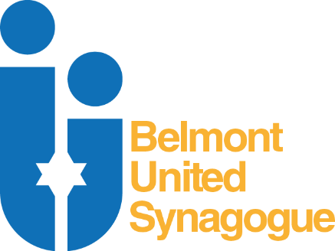
LINKS
FOR RECURRING EVENTS

MONDAY Q&A WITH RABBI LEVENE
THURSDAY SOUL SEARCHING & DVAR TORAH
https://us02web.zoom.us/j/983232105

THURSDAY COFFEE & CONVERSATION
https://us02web.zoom.us/j/87478370977

WoW EVENTS
https://us02web.zoom.us/j/89686275035

KABBALAT SHABBAT
HAVDALAH
Rav Marc Levene’s Facebook Page

LADIES’ DISCUSSION GROUP
https://us04web.zoom.us/j/71852675726

